Analysis of Rear Wheels:

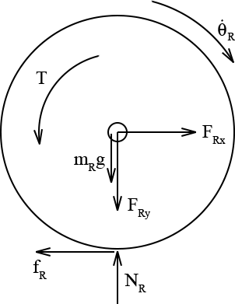

Euler’s Laws:

1.

2.

3.

Supplementary Equations:

If the wheel is off the ground:

4a.

5a.

If the wheel is slipping:

4b.

5b.

If the wheel is in rolling contact:

4c.

5c.

Analysis of Front Wheels:

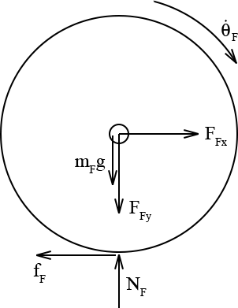

Euler’s Laws:

6.

7.

8.

Supplementary Equations:

If the wheel is off the ground:

9a.

10a.

If the wheel is slipping:

9b.

10b.

If the wheel is in rolling contact:

9c.

10c.

Analysis of Frame:

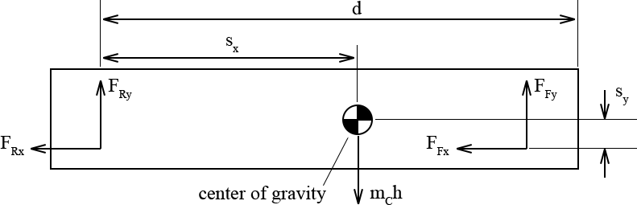

Euler’s Laws:

11.

12.

13.

Supplemental Kinematics Equations

The front and back wheels are a fixed distance from each other:

14.

15.

The frame’s center of mass is a fixed distance from the rear wheel:

16.

17.

In total, 17 equations with 17 unknowns. Phew!